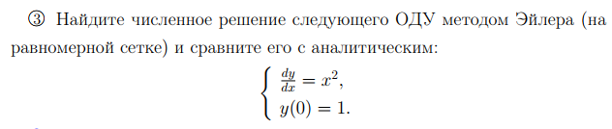

%f - функция первой производной y'=f(x)

%f0, x0 - начальное условие y(x0)=f0

%x0 - левый конец отрезка

%X - правый конец отрезка

%N - количество отрезков

function ChM7v1(f, f0, x0, X, N)

hold on, grid on

h=(X-x0)/N;

n_yi=f0 + h*f;

y=f0;

for i=x0+h:h:X

n_yi = n_yi + subs(f, i-h)*h;

y=[y, subs(n_yi, i)];

end

plot(x0:h:X, y);

end

>> ChM7v1(x^2, 1, 0, 1, 10)

>> ezplot(x^3/3+1,[0,1])



***Метод Эйлера имеет погрешность равную h***

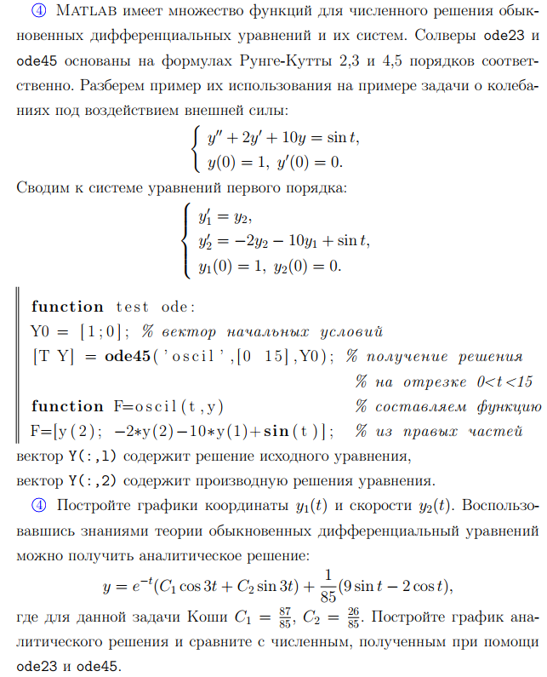

function F=oscil(t,y)

F=[y(2); -2*y(2)-10*y(1)+sin(t)];

end

function ChM_BDZ2v2()

Y0=[1;0];

figure(1)

hold on, grid on

ylabel('y')

xlabel('t')

[T Y] = ode23('oscil', [0 15], Y0);

plot(T,Y(:,1),'-')

figure(2)

ylabel('y''')

xlabel('t')

hold on, grid on

plot(T,Y(:,2),'-')

figure(1)

[T Y] = ode45('oscil', [0 15], Y0);

plot(T,Y(:,1),'-')

figure(2)

plot(T,Y(:,2),'-')

figure(1)

syms t

ezplot(exp(-t)*(87/85*cos(3*t)+26/85*sin(3*t))+1/85*(9*sin(t)-2*cos(t)), [0,15])

figure(2)

ezplot(diff(exp(-t)*(87/85*cos(3*t)+26/85*sin(3*t))+1/85*(9*sin(t)-2*cos(t)),1), [0,15])

ylim([-2.5,1])

end





function ChM_BDZ2v2()

Y0=[1;0];

figure(1)

hold on, grid on

xlabel('t')

ylabel('y')

[T Y] = ode23('oscil', [0 15], Y0);

plot(T,Y(:,1),'-')

figure(4)

hold on, grid on

xlabel('t')

ylabel('y''')

plot(T,Y(:,2),'-')

figure(2)

hold on, grid on

xlabel('t')

ylabel('y')

[T Y] = ode45('oscil', [0 15], Y0);

plot(T,Y(:,1),'-')

figure(5)

hold on, grid on

xlabel('t')

ylabel('y''')

plot(T,Y(:,2),'-')

figure(3)

hold on, grid on

xlabel('t')

ylabel('y')

syms t

ezplot(exp(-t)*(87/85*cos(3*t)+26/85*sin(3*t))+1/85*(9*sin(t)-2*cos(t)), [0,15])

ylim([-0.4, 1])

figure(6)

hold on, grid on

xlabel('t')

ylabel('y''')

ezplot(diff(exp(-t)*(87/85*cos(3*t)+26/85*sin(3*t))+1/85*(9*sin(t)-2*cos(t)),1), [0,15])

ylim([-2.5, 1])

end













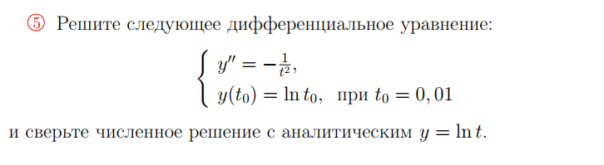

function F=oscil2(t,y)

F=[y(2); -1/t^2];

end

[T Y] = ode23('oscil2', [0.01 15], [log(0.01);100]);

plot(T,Y(:,1))

hold on, grid on

ezplot(log(t))

[T Y] = ode45('oscil2', [0.01 15], [log(0.01);100]);

plot(T,Y(:,1))

ylabel('y')

